

Experiment 8 Formal Report

Course:_EEM206_

Name :Cansu Ceylan
Lab section :F
Lab TA :Seval ÖREN
Date :25.12.2019

Abstract

EEG (Electroencephalogram) is a painless and non-sided iagnostic method in which the electrical activity produced by nerve cells in the brain is monitored both by wakefulness and sleep. The nervecells that form the brain are in constant interaction with eachother and generate electrical signals from this interaction. EEG assists in the diagnosis of various brain diseases such as head trauma, brain tumors, memory disorders, sleep disorders, encephalitis and encephalopathy with this interaction.

The aim of theproject is to obtain EEG signals from the brain with the help of electrodes and to display these signals in a clean and smooth manner. First, the electrodes were placed in certain areas of the scalp with the help of a gel. The signals obtained as a result of this process are quite small. In order to observe the signals easily, firstly the amplification operation must be done.This operation was done using an instrumentation amplifier. Subsequently, various filter circuits were used to eliminate the noise in the signals obtained. As a result, analog EEG signals were converted to digital signals using A / D(Analog to Digital)converter. These signals were displayed on computer with the help of LabView program. Finally, the signals were digitally filtered using the Matlab program and the signals were separated by frequency transformations by the FFT (FastFourierTransform) transformation.


Table of Contents

Introduction 1
Lab Methodology
Analytical Summary 2,3
Experimental Equipment and Procedure 6
Lab Analysis
Results 7
Discussion 7
Conclusions 8

Introduction

The human body is a good conductor.Therefore, it collects all signals emitted to the environment. These signals are called noise.Noise signals are signals with the same potential.Biopotential signals are signals with different potential.

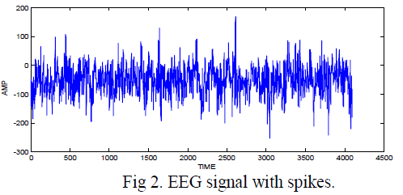

Since the EEG signals are at µV levels, they must pass through the pre-amplifier stage. Electroencephalography ,or EEG, is the physiological method of choice to record the electrical activity generated by the brain via electrodes placed on the scalp surface. For faster application, electrodes are mounted in elastic caps similar to bathing caps, ensuring that the data can be collected from identical scalp positions across all respondents.Shortly EEG, measures electrical activity generated by the synchronized activity of thousands of neurons (in volts). The EEG signal itself has several components separated by frequency.

Lab Methodology

Analytical Summary
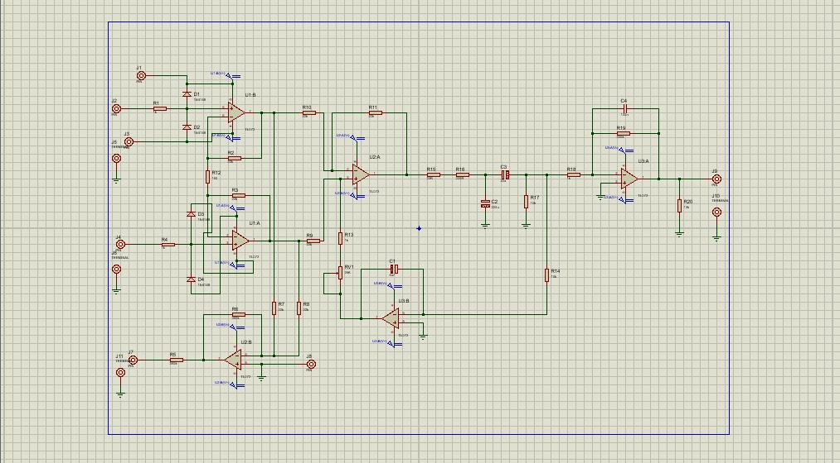
We designed the circuit in Proteus.
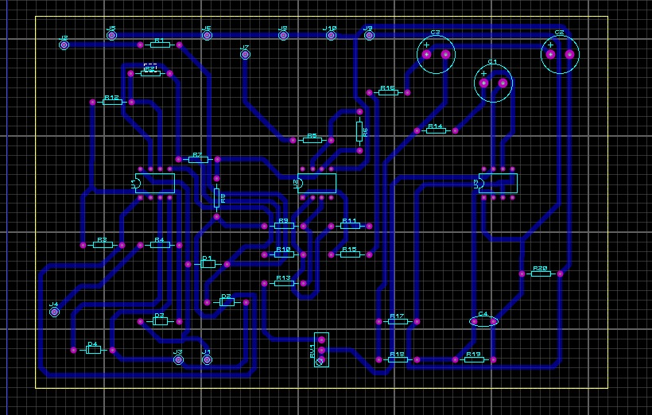
We transferred the circuit to isis.
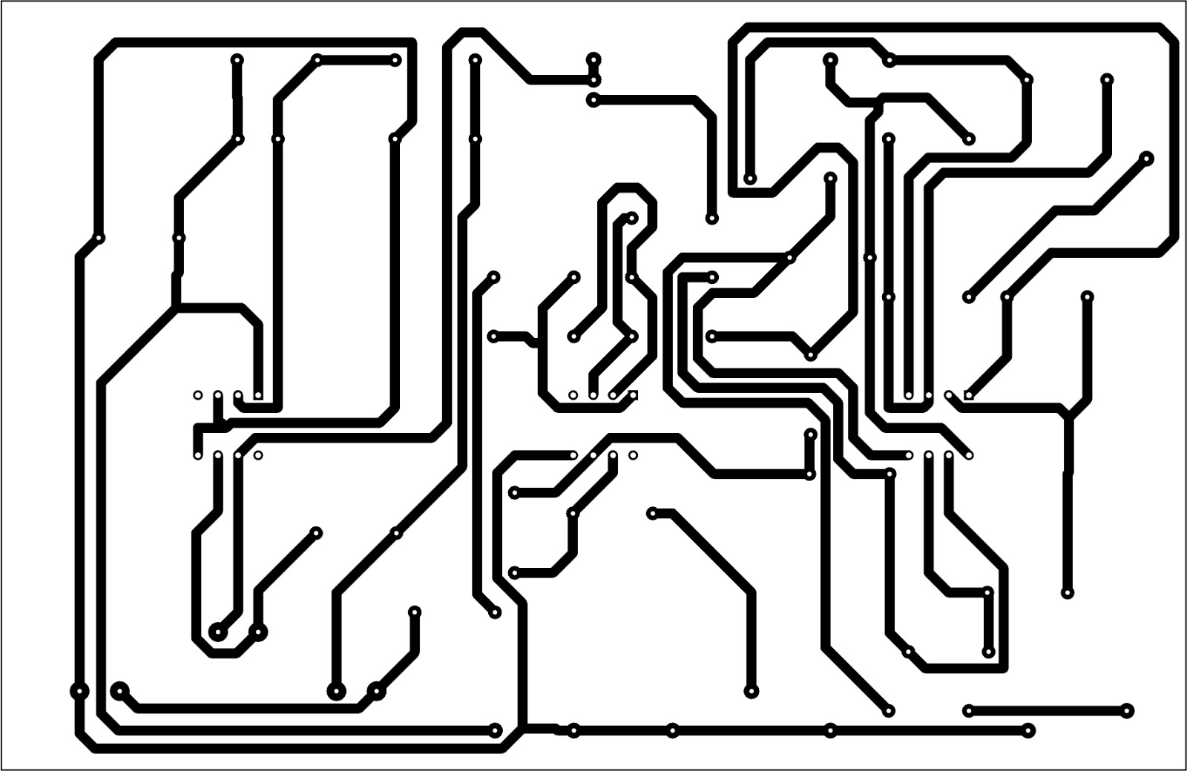
Circuit is ready to be printed.
We pressed the circuit to copper sheet.
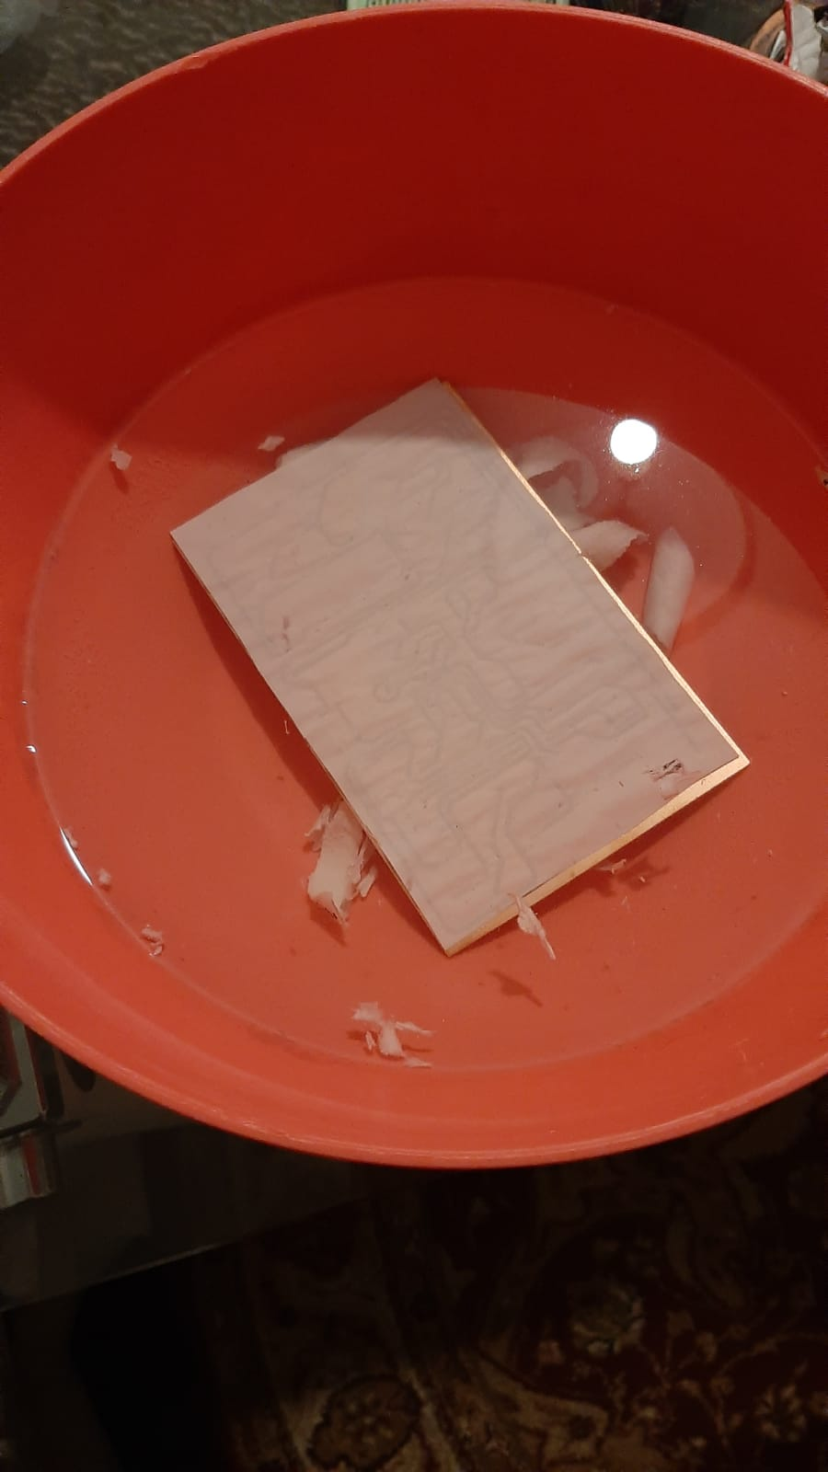
We erased the sheet thanks to water.
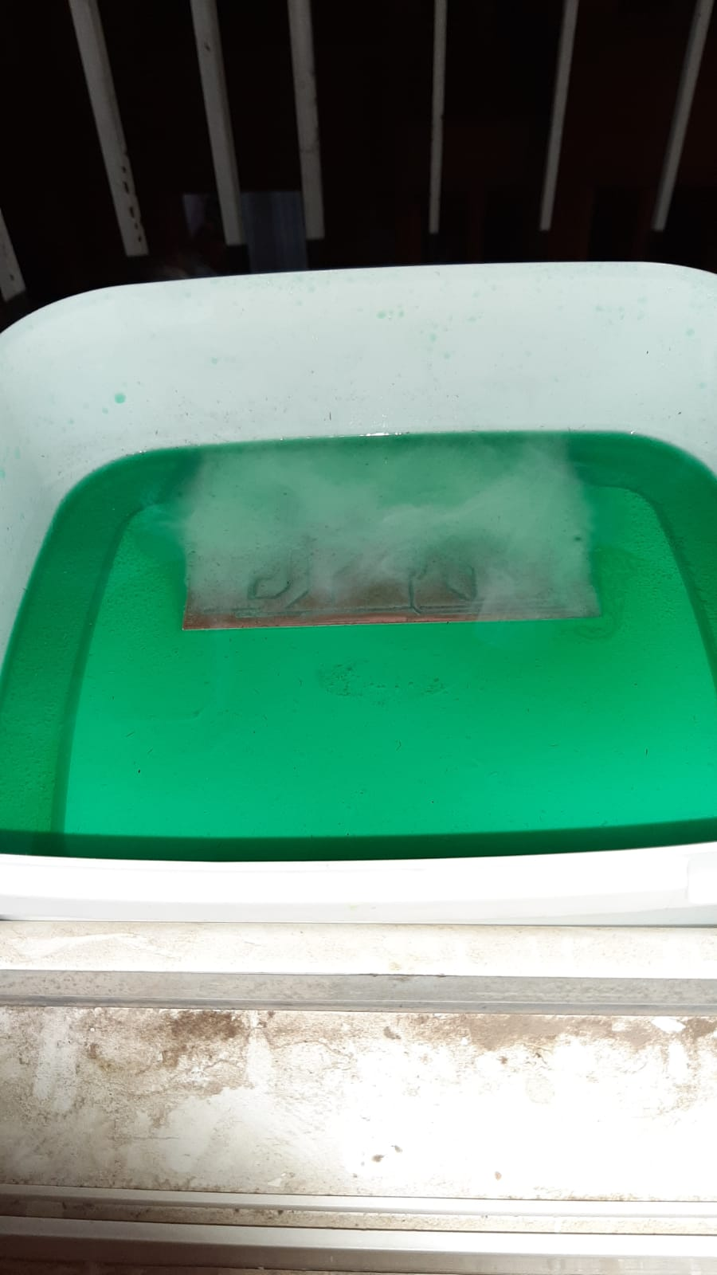
With chamical equipments, we melted the top layer of the copper to see the circuit.
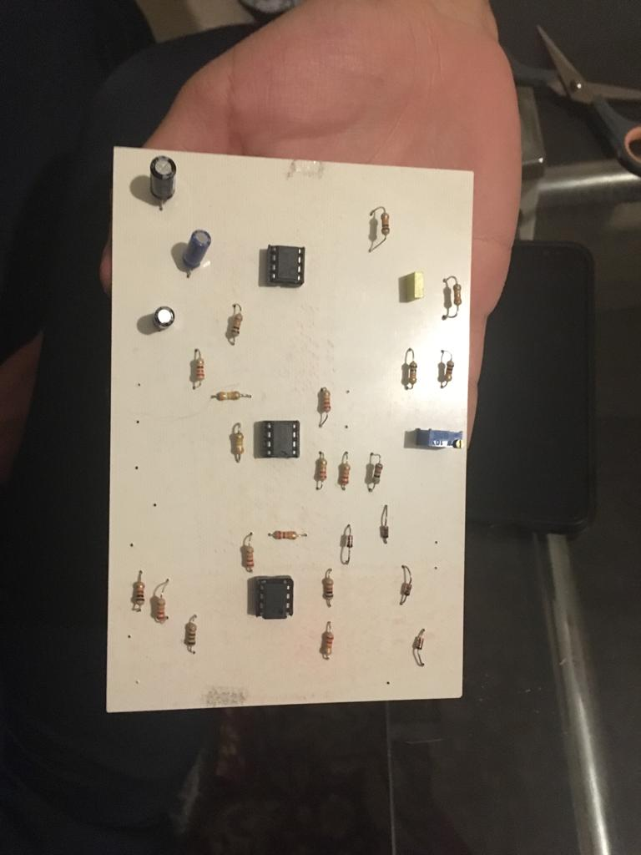
We connected the equipments to the copper and had the circuit ready.
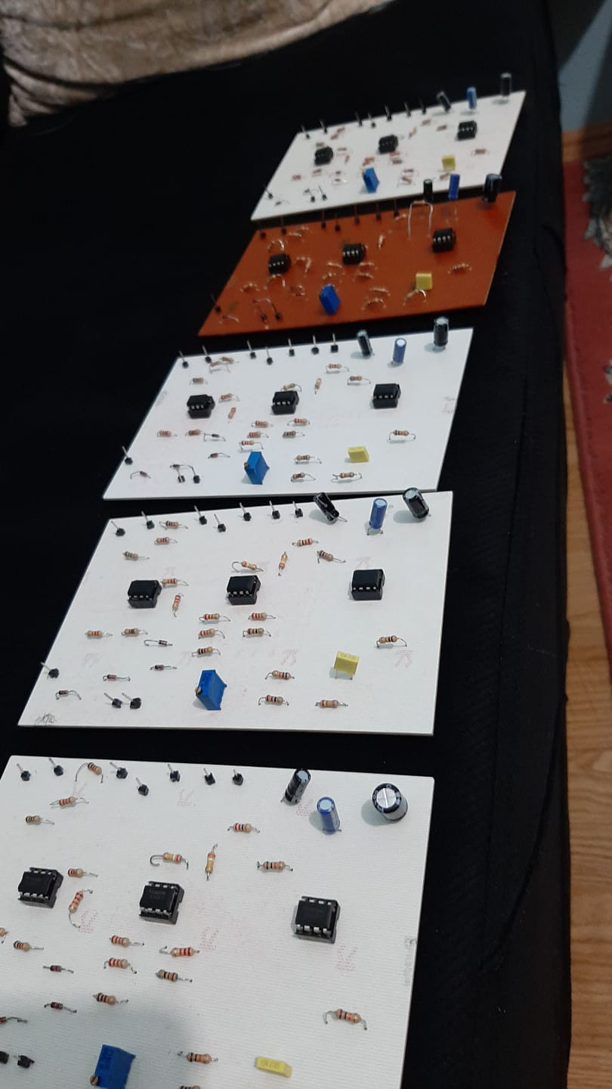
That was all for the EEG circuit.

Experimental Equipment and Procedure
PART-A SERIES TUNED CIRCUlT
Materials Required:
- Opamp Pouch *3
- TL02 Opamp *2
- 1N4148 Diode *4
- 50K trimpot*1
- 4.7 mf capacitor *1
- 220 mf capacitor *1
- 22 mf capacitor *1
- 100 nf capacitor *1
- 22k Ohm Resistor*4
- 390k Ohm Resistor*7
- 22 Ohm Resistor*2
- 220 Ohm Resistor*1
- 10k Ohm Resistor*1
- 330k Ohm Resistor*3
- 150 Ohm Resistor*1
- Copper sheet

Procedure:
Procedure is shown with photos.

Lab Analysis

Results
We struggled a lot to build this EEG circuit. It was an interesting experiment. We failed too much in the processes but we enjoyed it. While doing this experiment, we learned what is EEG for and how it is built. It is not too much expensive to have an EEG. We can build it in a cheap way. I think it wil be a bridge between electrical and electronics engineering and health sector. I will try to direct myself to this area in my academic life.

Discussion
This experiment helped me a lot on understanding the charachterization of EEG circuits. Before the experiment we searched the EEG and we bought the equipments needed. When we started the building progress, we made some mistakes and we had to start again for two or three times. Finally we successed to had the circuit. We brought it to the labarotory but it didn’t give any output signals.

Conclusions
First, the electrodes were placed in specific regions of a gel regional scalp. The signals obtained are small amplitudes. In order for the signals to be observed easily, they must first undergo a progress. This was done at an instrumentation amplifier. Then, various filter circuits were used to eliminate the translation of the obtained signals. The EEG signals were converted into A / D dial-up digital signals. These signals are also displayed on thecomputer in LabView.

